|  |  |  |  |  |  |  |
| --- | --- | --- | --- | --- | --- | --- |
| LITERATURE REVIEW | | | | | | |
|  | S.NO  1. | TITLE &  AUTHOR | YEAR &  PUBLICATIONS | METHODOLOGY & ALGORITHM | ADVANTAGE | DRAWBACK |
| Artificial  Intelligence in  Nutrients  Science      BALAKRISH  NA .Y | **JUNE 2022**    This article belongs to the Section Nutrition  Methodology &  Assessment | The possibilities of artificial intelligence in the field of medical diagnostics, risk prediction and support of therapeutic.    AI algorithms may help better understand and predict the complex and non-linear interactions between nutrition-related data and health. | creation of a global network that will be able to both actively support and monitor the personalized supply of nutrients. | The AI System  May Be Buggy  At First it can take time to work correctly. This is normal. |
| 2. | Artificial intelligence in food science and nutrition    Informatio n  Technologi  es Institute  (ITI)  Kosmas Dimitropou  los | **April 2019**  Published by  Oxford  University Press on behalf of the International Life Sciences  Institute. | AI in areas such as immunity-boosting foods, dietary assessment, gut microbiome profile analysis, and toxicity prediction of food ingredients.chniques are growing rapidly.    They are a type of ML algorithms that requires very little human supervision when training and can crunch huge amounts of data in a short time. As for their application in healthcare, ANNs are used to analyze medical imaging, biochemical studies | tells exactly what to eat according to the body type. All of this is packaged in a  comprehensive nutrition and activity tracker. | The AI system may not always make the right decisions, but it will eventually learn from these errors and  adjust its decision-making processes to improve over time. |
| 3. | Android  Based  Monitoring  System  With Diet  And Calorie  Tracker    V.  Ramkumar, S.Priyanga Devi , K.  Laxmi Priya, M.  Kavya Dharshani. | **AUG 2022**            Publisher Name  IJERT | It serves as a calorie tracker, allowing users to lose weight and track their food and exercise regimens through their phones.        The A.I. Diet is an algorithm that tells you how to eat to live a longer and healthier life. As you know, an algorithm is a process or set of rules followed by a computer used in calculations or problem-solving, so the  A.I diet is all based on science | the fitness coach is an AI that can handle  77% of all user  questions, | It is clearly lacking appropriate regulations and some political, ethical, and financial transformations |
|  | | | | | |

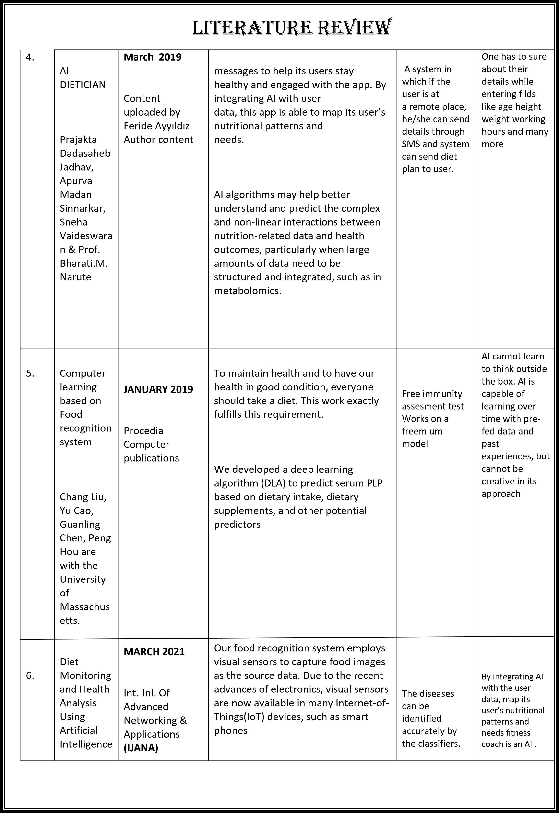

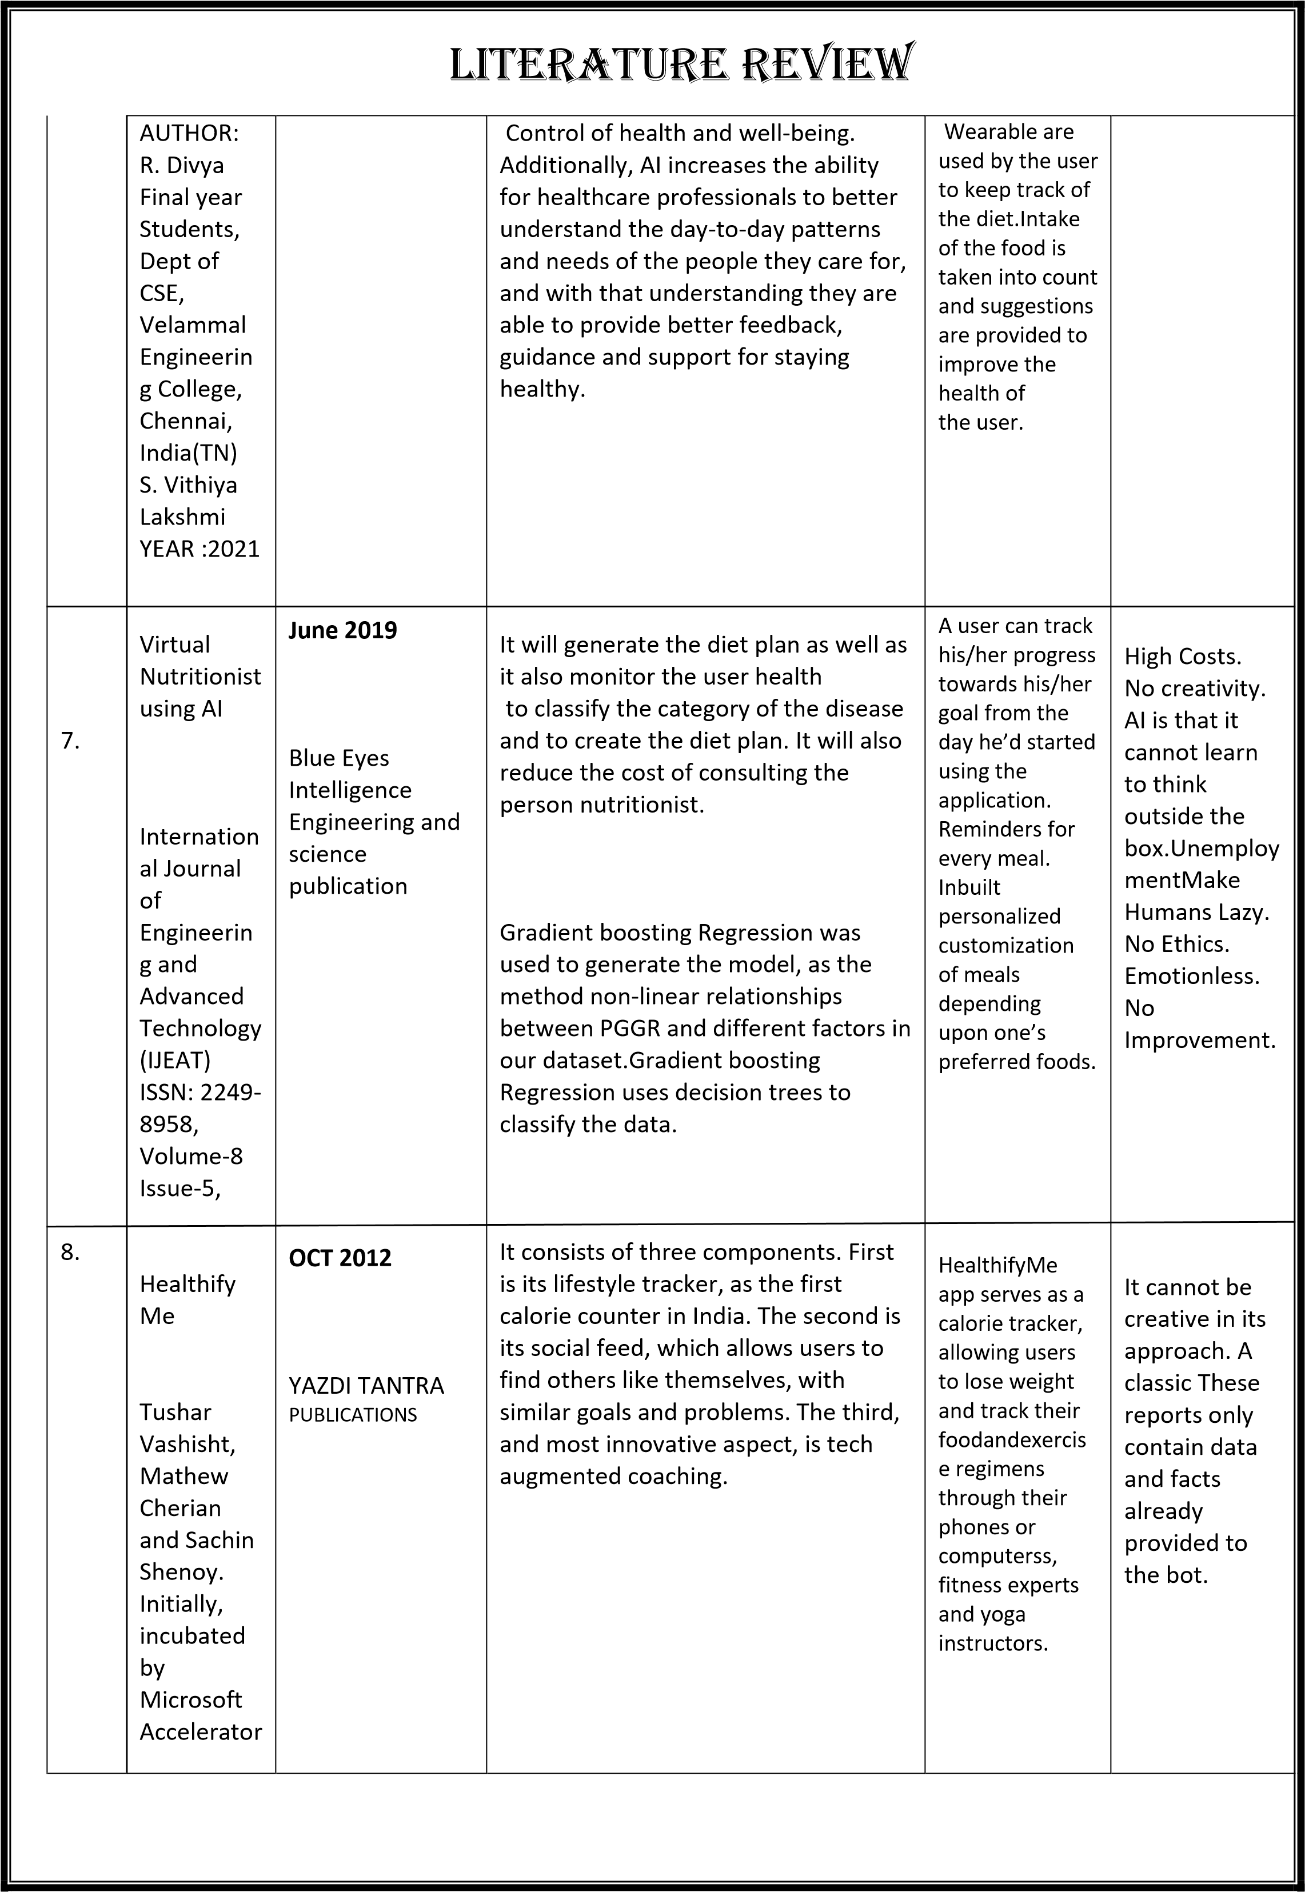

|  |  |  |  |  |  |  |
| --- | --- | --- | --- | --- | --- | --- |
| LITERATURE REVIEW | | | | | | |
|  | 9. | AI-Based  Dietician        Professor,  Departmen  t of  Computer  Science,  Dayananda  Sagar  Academy  of  Technology | **April 2022**        International  Journal of  Creative  Research  Thoughts (IJCRT) | Consulting a dietician is something that everyone cannot afford. Also, consulting a dietician could be time-consuming. An expert system method to recommend a personalized diet plan.      AI could significantly improve packaging, increasing shelf life, a combination of the menu by using AI algorithms, and food safety by making a more transparent supply chain management system. | Helps the user to interact better with the system, Provide information to the system as input and take the  recommended  diet plan as output. | Doesn't have acknowledgable  dietician Don't value customer time Worst service. |
| 10. | A  Computer  Visionbased Indian  Food Detection and  Nutrition  Calculation  App          Durgesh  Samariya | **MAY 2022**          DEVELOPERS  CORNER | The task of food detection/classification is not easy as it seems. all possible options related to the given Image. For example, if a user uploads a dal image then the Foodify.ai app return all dal’s from our nutrition database such as Dal Tadka, Dal Fry, Dal Makhni, etc.      AI algorithms can help the food delivery systems to manage the orders  accurately. It will reflect the customer's order to two different delivery partners, one who is in the nearby location of the delivery address and the other who is in the nearby location of the restaurant where the customer has ordered the food | Easy to use Highly productive  No more man power required | Calculation cannot be accurate Software development is  difficult  Image processing can always not be correct |
|  | | | | | |